**Experiment No.:** 05

**Experiment Name:** Configuring a Virtual Local Area Network (VLAN) Topology.

**Objective:**

* To learn computer networking protocols
* To learn basics of VLAN
* To configure a network using VLAN

**Introduction:**

A Virtual Local Area Network (VLAN) is a subnetwork which can group together collections of devices on separate physical Local Area Networks (LANs). A LAN is a group of computers and devices that share a communications line or wireless link to a server within the same geographical area.

VLANs make it easy for network administrators to [partition](https://searchstorage.techtarget.com/definition/partition) a single switched network to match the functional and security requirements of their systems without having to run new cables or make major changes in their current network infrastructure. VLANs are often set up by larger businesses to re-partition devices for better traffic management. VLANs are also important because they can help improve the overall performance of a network by grouping together devices that communicate most frequently. It also provides security on larger networks by allowing a higher degree of control over which devices have access to each other. VLANs tend to be flexible because they are based on logical connections, rather than physical.

There are Three types of VLANs:

* Protocol VLAN - which has traffic handled based on its protocol. A switch will segregate or forward traffic based on the traffics protocol.
* Static VLAN - also referred to as port-based VLAN, needs a network administrator to assign the ports on a network switch to a virtual network; while:
* Dynamic VLAN - allows a network administrator just to define network membership based on device characteristics, as opposed to switch port location.

**Topology:**

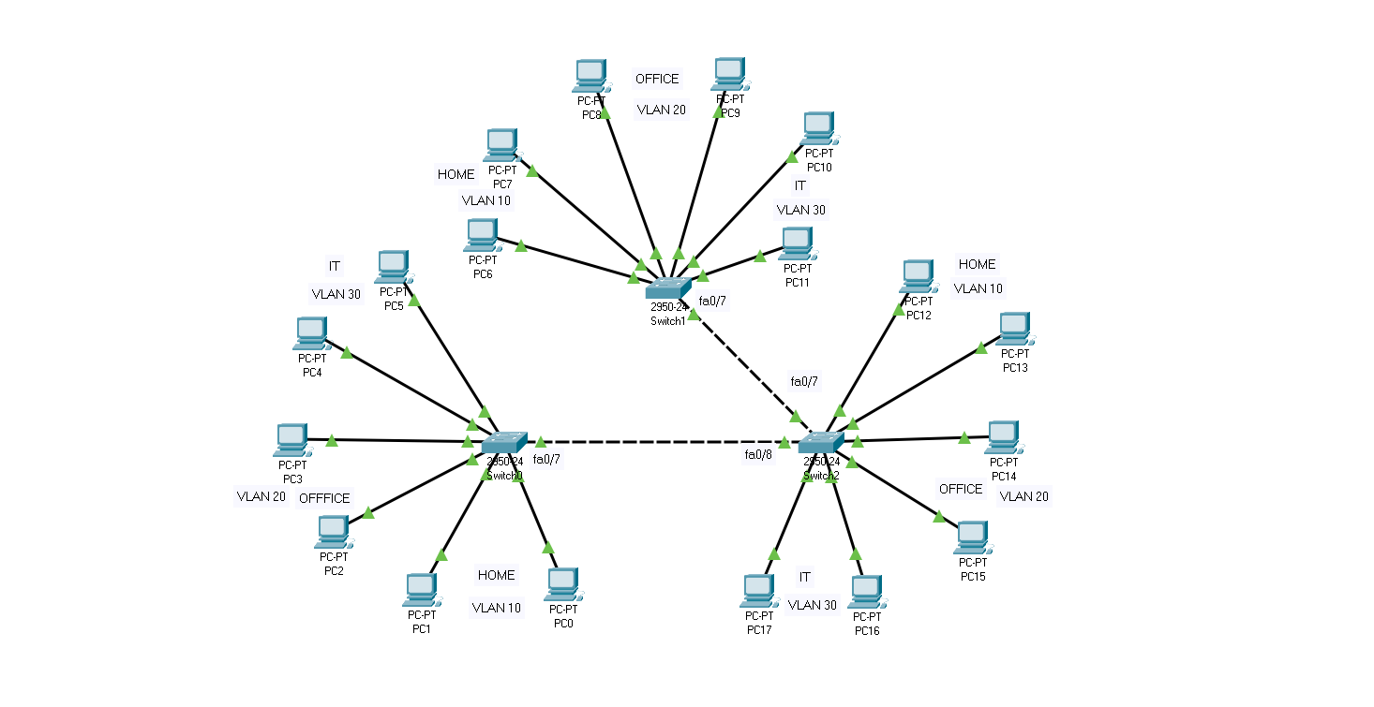

Fig: A Virtual Local Area Network (VLAN) Design

**Command:**

1. **Home PC Configuration: (VLAN 10)**

**PC-PT PC0:**

**IP Address:** 192.168.10.1

**Subnet Mask:** 255. 255. 255. 0

**PC-PT PC0:**

**IP Address:** 192.168.10.2

**Subnet Mask:** 255. 255. 255. 0

**PC-PT PC0:**

**IP Address:** 192.168.10.3

**Subnet Mask:** 255. 255. 255. 0

**PC-PT PC0:**

**IP Address:** 192.168.10.4

**Subnet Mask:** 255. 255. 255. 0

**PC-PT PC0:**

**IP Address:** 192.168.10.5

**Subnet Mask:** 255. 255. 255. 0

**PC-PT PC0:**

**IP Address:** 192.168.10.6

**Subnet Mask:** 255. 255. 255. 0

1. **Office PC Configuration: (VLAN 20)**

**PC-PT PC0:**

**IP Address:** 192.168.20.1

**Subnet Mask:** 255. 255. 255. 0

**PC-PT PC0:**

**IP Address:** 192.168.20.2

**Subnet Mask:** 255. 255. 255. 0

**PC-PT PC0:**

**IP Address:** 192.168.20.3

**Subnet Mask:** 255. 255. 255. 0

**PC-PT PC0:**

**IP Address:** 192.168.20.4

**Subnet Mask:** 255. 255. 255. 0

**PC-PT PC0:**

**IP Address:** 192.168.20.5

**Subnet Mask:** 255. 255. 255. 0

**PC-PT PC0:**

**IP Address:** 192.168.20.6

**Subnet Mask:** 255. 255. 255. 0

1. **IT PC Configuration: (VLAN 30)**

**PC-PT PC0:**

**IP Address:** 192.168.30.1

**Subnet Mask:** 255. 255. 255. 0

**PC-PT PC0:**

**IP Address:** 192.168.30.2

**Subnet Mask:** 255. 255. 255. 0

**PC-PT PC0:**

**IP Address:** 192.168.30.3

**Subnet Mask:** 255. 255. 255. 0

**PC-PT PC0:**

**IP Address:** 192.168.30.4

**Subnet Mask:** 255. 255. 255. 0

**PC-PT PC0:**

**IP Address:** 192.168.30.5

**Subnet Mask:** 255. 255. 255. 0

**PC-PT PC0:**

**IP Address:** 192.168.30.6

**Subnet Mask:** 255. 255. 255. 0